**Challapata Market Update, 7.6.2014**

**Price Analysis**

The prices in Bolivia are still moving in an upward direction. Although prices (for red and

black quinoa) seemed to have stabilized at $4.83 (red) and $4.02 (black) in the month of

May, there is a movement of both prices in opposite directions. The demand for red

quinoa varieties must have increased, as prices do from $4.82 to $5.14 within a week.

Oppositely, the black quinoa price moves downwards from $4.02 to $3.21.

The price for white quinoa is even more fluctuating than the above mentioned prices.

Moving downwards from a peak of $5.80 on the 17th of May, the white quinoa prices

fall until $5.14 (24.5.) from where they raise weekly to $5.30 on the 31.5.2014 and

reach $5.62 last weekend on the 7th of June.

**Price Overview**

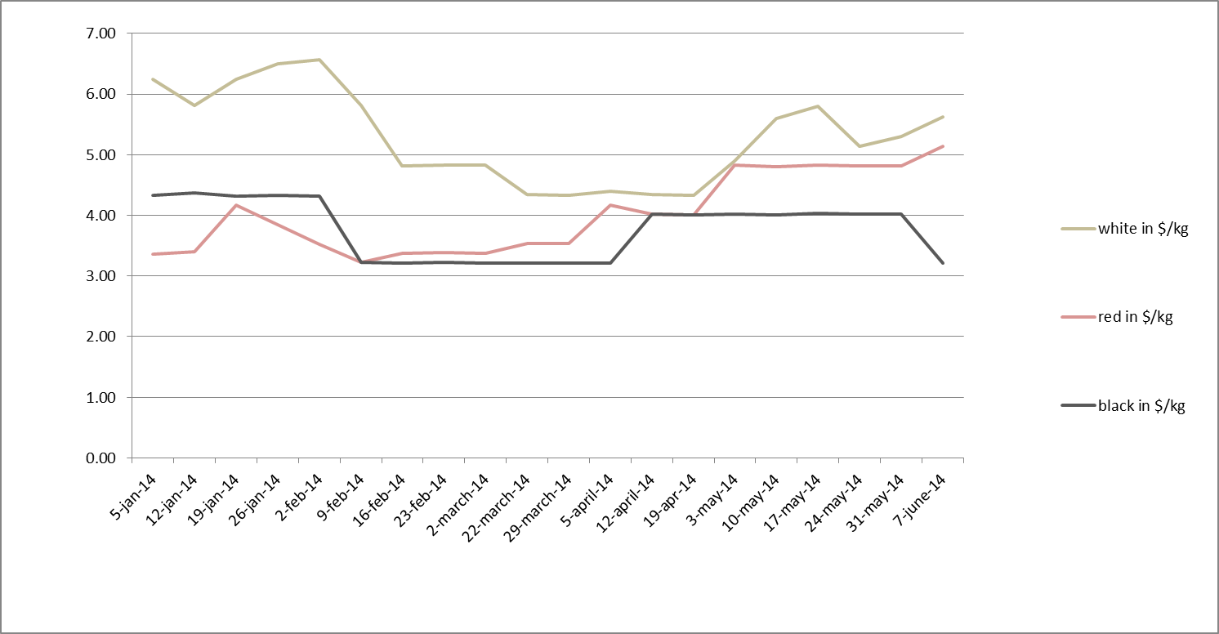

**Price Record**

|  |  |  |  |
| --- | --- | --- | --- |
|  | white | 1,950 | 6.24 |
| **5-jan-14** | red | 1,050 | 3.36 |
|  | black | 1,350 | 4.32 |
|  |  |  |  |
|  | white | 1,800 | 5.82 |
| **12-jan-14** | red | 1,050 | 3.39 |
|  | black | 1,350 | 4.36 |
|  |  |  |  |
|  | white | 1,950 | 6.24 |
| **19-jan-14** | red | 1,300 | 4.16 |
|  | black | 1,350 | 4.32 |
|  |  |  |  |
|  | white | 2,030 | 6.50 |
| **26-jan-14** | red | 1,200 | 3.84 |
|  | black | 1,350 | 4.33 |
|  |  |  |  |
|  | white | 2,050 | 6.56 |
| **2-feb-14** | red | 1,100 | 3.52 |
|  | black | 1,350 | 4.32 |
|  |  |  |  |
|  | white | 1,800 | 5.81 |
| **9-feb-14** | red | 1,000 | 3.23 |
|  | black | 1,000 | 3.23 |
|  |  |  |  |
|  | white | 1,500 | 4.82 |
| **16-feb-14** | red | 1,050 | 3.37 |
|  | black | 1,000 | 3.21 |
|  |  |  |  |
|  | white | 1,500 | 4.83 |
| **23-feb-14** | red | 1,050 | 3.38 |
|  | black | 1,000 | 3.22 |
|  |  |  |  |
|  | white | 1,500 | 4.82 |
| **2-march-14** | red | 1,050 | 3.38 |
|  | black | 1,000 | 3.22 |
|  |  |  |  |
|  | white | 1,350 | 4.34 |
| **22-march-14** | red | 1,100 | 3.54 |
|  | black | 1,000 | 3.21 |
|  |  |  |  |
|  | white | 1,350 | 4.33 |
| **29-march-14** | red | 1,100 | 3.53 |
|  | black | 1,000 | 3.21 |
|  |  |  |  |
|  | white | 1,370 | 4.40 |
| **5-apr-14** | red | 1,300 | 4.17 |
|  | black | 1,000 | 3.21 |
|  |  |  |  |
|  | white | 1,350 | 4.34 |
| **12-apr-14** | red | 1,250 | 4.02 |
|  | black | 1,250 | 4.02 |
|  |  |  |  |
|  | white | 1,350 | 4.33 |
| **19-apr-14** | red | 1,250 | 4.01 |
|  | black | 1,250 | 4.01 |
|  |  |  |  |
|  | white | 1,520 | 4.89 |
| **3-may-2014** | red | 1,500 | 4.83 |
|  | black | 1,250 | 4.02 |
|  |  |  |  |
|  | white | 1,750 | 5.60 |
| **10-may-2014** | red | 1,500 | 4.80 |
|  | black | 1,250 | 4.00 |
|  |  |  |  |
|  | white | 1,800 | 5.80 |
| **17-may-2014** | red | 1,500 | 4.83 |
|  | black | 1,250 | 4.03 |
|  |  |  |  |
|  | white | 1,600 | 5.14 |
| **24-may-2014** | red | 1,500 | 4.82 |
|  | black | 1,250 | 4.02 |
|  |  |  |  |
|  | white | 1,650 | 5.30 |
| **31-may-2014** | red | 1,500 | 4.82 |
|  | black | 1,250 | 4.02 |
|  | |  |  |  |
|  | white | 1,750 | 5.62 |
| **7-june-2014** | red | 1,600 | 5.14 |
|  | black | 1,000 | 3.21 |

**The Meaning of the Challapata Price**

The price figures below give an insight into the market price for Bolivian quinoa as it is determined weekly on the Challapata market in the Bolivian Southern Altiplano. Challapata is the main national open market for quinoa, named “Quinoa Wallstreet” for the consequences its price setting dynamics have on international trade. Every week, producers and traders from all over the country come to the small town to buy and sell quinoa. The price for which the grain is traded is decided weekly and can raise or drop within the day. The Challapata price is determined by supply and demand. It is so important since it is the benchmark for most exporting companies and associations. The price politics of most companies take the Challapata price as a basis and then adds 50, 60 or 100 Bolivianos extra.

At Mercadero, we update the Challapata price every fortnight and explain why the price moves in a certain direction. The price refers to white quinoa, which can be both organic and non-organic but should mainly be sold as non-organic due to the spot market character of the Challapata market (hence, back-tracing is not easily done).

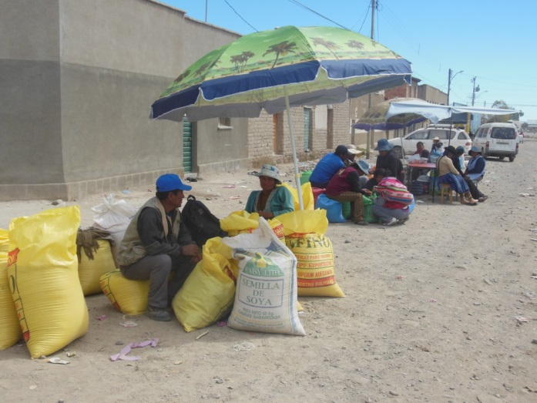**Quinoa farmers and their produce in Challapata, Picture: Annika Gabriel, March 2013.**